Competitor Intelligence Agent: A LangGraph-Powered Conversational AI System for Retail Market Analysis

1. Introduction
Retail businesses operating in highly competitive commercial hubs require continuous visibility into their local market environment to remain competitive. Clothing stores, in particular, face challenges in understanding competitor density, customer footfall trends, peak operating periods, and market saturation levels. Traditional market research methods are often manual, time-consuming, and quickly become outdated.
To address this challenge, a Competitor Intelligence Agent was developed using LangGraph, Large Language Models (LLMs), Retrieval-Augmented Generation (RAG), and real-time external data sources. The system provides businesses with actionable competitor intelligence by automatically identifying nearby clothing stores, enriching competitor profiles with traffic intelligence, generating strategic insights, and maintaining long-term memory of previous analyses.
The solution transforms raw location-based business data into executive-level business intelligence reports that support decision-making for store owners, marketing teams, real estate analysts, and investors.

2. Problem Statement
Businesses in competitive retail locations require timely insights into:
- Nearby competitors
- Customer footfall trends
- Peak operating periods
- Market leaders
- Competitive intensity
- Market opportunities
The objective was to design a conversational AI pipeline capable of:
- Discovering nearby clothing store competitors.
- Collecting real-time business intelligence.
- Analyzing footfall and traffic patterns.
- Generating actionable strategic recommendations.
- Supporting conversational querying through memory and retrieval mechanisms.

3. Objectives
The primary objectives of the project were:
- Develop a LangGraph-based agent workflow.
- Integrate multiple external intelligence sources.
- Generate competitor intelligence reports automatically.
- Provide data-driven business recommendations.
- Enable conversational interaction with historical analyses.
- Support report export and dashboard visualization.

4. System Architecture
The system follows an agentic workflow orchestrated using LangGraph StateGraph.
User Query
↓
LangGraph StateGraph
↓
Competitor Search Node
↓
Traffic Enrichment Node
↓
Analytics Node
↓
Reflection Node
↓
Executive Summary Node
↓
Chroma Memory
↓
Gemini Memory Assistant
↓
Streamlit Dashboard
↓
PDF / Excel Export

The architecture separates data acquisition, enrichment, reasoning, reflection, reporting, and memory management into modular components.

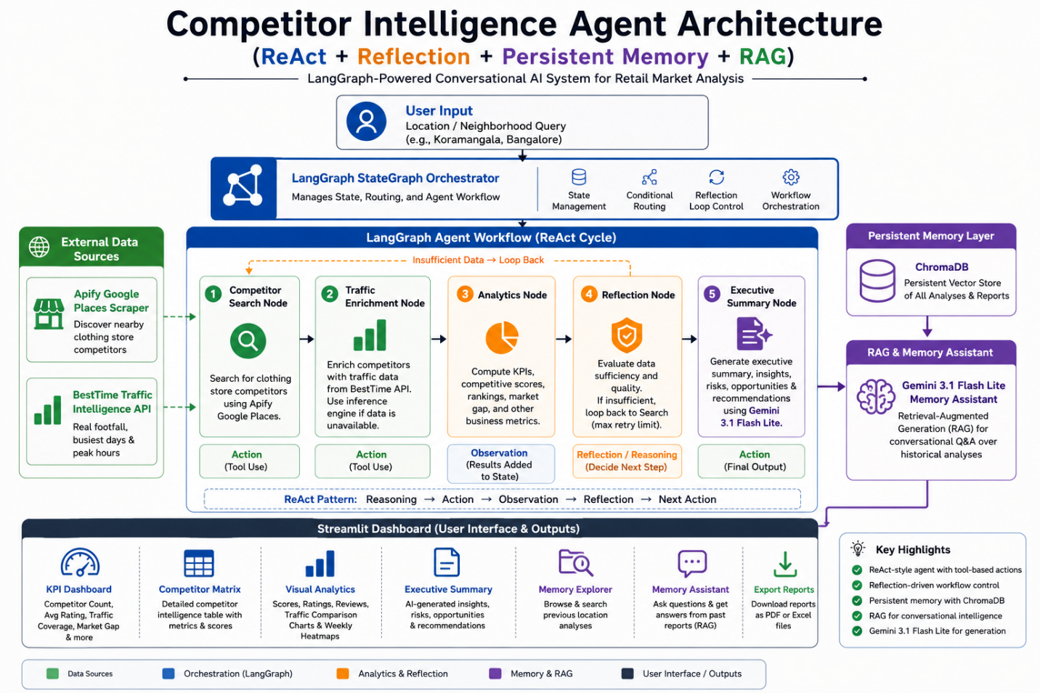

5. Technology Stack

Frameworks
- LangGraph
- LangChain
- Streamlit

Large Language Model
- Google Gemini 3.1 Flash lite

Vector Database
- ChromaDB

Data Sources
- Apify Google Places Scraper
- BestTime Traffic Intelligence API

Visualization
- Plotly
- Pandas

Export Utilities
- ReportLab
- OpenPyXL

6. LangGraph Workflow Design
A StateGraph was implemented to orchestrate the agent workflow.

Search Node
Discovers clothing store competitors within the specified location using Apify’s Google Places crawler.

Enrichment Node
Enhances competitor profiles using:
- BestTime empirical traffic intelligence
- Analytical traffic inference fallback engine

Analytics Node
Computes:
- Average ratings
- Review distributions
- Market gap metrics
- Competitive scores
- Traffic coverage statistics

Reflection Node
Validates data sufficiency and determines whether the collected intelligence is adequate for strategic reporting.

Summary Node
Uses Gemini to generate:
- Executive summaries
- Risks
- Opportunities
- Strategic recommendations
Conditional routing is implemented within LangGraph, allowing the workflow to revisit search operations if reflection determines that available intelligence is insufficient.

6.1 ReAct-Inspired Agent Design
The system follows a ReAct (Reasoning and Acting) inspired design pattern. Instead of generating a report in a single LLM call, the agent performs a sequence of reasoning and action steps to gather, validate, and synthesize market intelligence.
The workflow consists of:
- Reasoning Phase – The agent determines which tool or workflow node should execute next.
- Action Phase – The selected node performs a specific task such as competitor discovery, traffic enrichment, analytics generation, or report synthesis.
- Observation Phase – Results from the executed node are added to the shared LangGraph state.
- Reflection Phase – The Reflection Engine evaluates whether sufficient intelligence has been collected and determines whether the workflow should continue or terminate.
This iterative reasoning-action-observation cycle enables the system to progressively build a comprehensive competitor intelligence report rather than relying on a single-pass response generation approach.
The combination of ReAct-style reasoning, LangGraph orchestration, and reflection-based validation improves reliability, transparency, and decision quality.

7. Traffic Intelligence Layer
A major challenge encountered during development was obtaining reliable footfall and peak-hour information.
Initial experiments using Google Places revealed that popularTimesHistogram data was unavailable for many local retail stores.
To overcome this limitation, the system integrates BestTime.app, which provides empirical traffic intelligence derived from aggregated mobile location signals.
The system automatically:
- Retrieves traffic profiles where available.
- Extracts busiest days.
- Computes average traffic percentages.
- Identifies peak traffic periods.
When empirical data is unavailable, an analytical inference engine generates realistic traffic estimates using:
- Review volume
- Store popularity indicators
- Retail behavioral assumptions
This dual-layer strategy ensures complete traffic coverage across all discovered competitors.

8. Competitive Analytics Engine
The analytics engine calculates multiple business intelligence metrics including:

Market Metrics
- Competitor Count
- Average Rating
- Traffic Coverage
- Empirical Coverage
- Market Gap

Competitive Scores
A weighted scoring mechanism evaluates competitors based on:
- Rating Performance
- Review Volume
- Traffic Strength
These metrics enable automatic identification of market leaders and high-performing competitors.

9. Reflection Mechanism
A reflection layer was incorporated to improve reliability.
The Reflection Engine evaluates:
- Competitor count
- Traffic coverage
- Data completeness
- Analytical confidence
The engine produces one of two outcomes:
- SUFFICIENT
- INSUFFICIENT
This validation step ensures that strategic recommendations are generated only after adequate market intelligence has been collected.

10. Memory and Conversational Intelligence
To support long-term learning and historical analysis, a persistent memory layer was implemented using ChromaDB.
Each completed analysis is stored as a vectorized business intelligence record.
Users can:
- Search historical analyses.
- Retrieve previous market reports.
- Compare locations.
- Ask follow-up business questions.
A Gemini-powered Memory Assistant uses Retrieval-Augmented Generation (RAG) to answer questions using stored intelligence.
Example queries include:
- Which location had the highest market gap?
- Which competitor consistently dominates traffic?
- Summarize all previously analyzed markets.

11. User Interface
A Streamlit dashboard was developed to provide an interactive user experience.
The dashboard includes:

KPI Dashboard
- Competitor Count
- Average Rating
- Traffic Coverage
- Empirical Coverage
- Market Gap

Competitor Overview Table
Detailed competitor intelligence matrix.

Visual Analytics
- Competitive Score Charts
- Ratings Analysis
- Reviews Analysis
- Traffic Comparison Charts
- Weekly Traffic Heatmaps

Executive Summary
AI-generated strategic business recommendations.

Memory Explorer
Historical analysis retrieval.

Memory Assistant
Conversational querying over stored intelligence.

Report Export
- PDF Reports
- Excel Reports

12. Results
The system successfully analyzed multiple clothing store competitors within Koramangala, Bangalore.
Key outcomes included:
- Automatic competitor discovery.
- Real-time traffic intelligence enrichment.
- Market leader identification.
- Strategic recommendation generation.
- Long-term memory retention.
- Conversational business intelligence retrieval.
The resulting platform provides significantly richer insights than traditional location-based competitor searches.

13. Challenges and Solutions
Challenge | Solution
Missing Google Popular Times Data | Integrated BestTime Traffic Intelligence API
Limited Footfall Availability | Built analytical inference fallback engine
Data Sufficiency Validation | Implemented Reflection Engine
Multi-step Agent Orchestration | Adopted LangGraph StateGraph
Historical Querying | Integrated ChromaDB Memory + RAG

14. Future Enhancements
Potential future improvements include:
- Multi-location comparative analysis.
- Geospatial competitor mapping.
- Multi-agent specialist architecture.
- Trend forecasting using historical traffic patterns.
- Automated business opportunity detection.

15. Conclusion
This project demonstrates the development of a LangGraph-powered ReAct-style Competitor Intelligence Agent that combines reflection-driven workflow control, persistent memory, Retrieval-Augmented Generation (RAG), and real-time market intelligence sources to support retail business decision-making.
The system combines agentic workflows, reflection mechanisms, traffic intelligence, long-term memory, and conversational analytics to transform raw competitor data into actionable business insights.
Beyond satisfying the original problem requirements, the project demonstrates how modern AI agents can support strategic retail decision-making through automated market intelligence generation and conversational business analysis.

